Group:63
S.No | Name | ID
1 | Pothineni Prasanna Sai Ram | 2024aa05379
2 | SHASHIDHAR K JAMBANOUR | 2024ab05170
3 | SHAAN ANSHU | 2024ab05201
4 | SHAIK RABIYA NIKHAT | 2024ab05062
5 | SHIVAM DWIVEDI | 2024aa05951

Task 1: Data Acquisition & Exploratory Data Analysis (EDA):
  - Dataset Description: The dataset used in this project is the heart disease dataset, commonly used for binary classification tasks to predict the presence of heart disease in patients based on clinical attributes.

Target Variable:
0 → No heart disease
1 → Presence of heart disease
Features include:
- Age
- Sex
- Chest pain type (cp)
- Resting blood pressure (trestbps)
- Serum cholesterol (chol)
- Fasting blood sugar (fbs)
- Resting ECG results (restecg)
- Maximum heart rate achieved (thalach)
- Exercise induced angina (exang)
- ST depression (oldpeak)
- Slope of peak exercise ST segment (slope)
- Number of major vessels (ca)
- Thalassemia (thal)

1.2 Dataset Source: The dataset was obtained from the UCI Machine Learning Repository and is also publicly available on Kaggle.
Dataset source: https://archive.ics.uci.edu/ml/datasets/heart+disease

1.3 Dataset Download Instructions: To ensure reproducibility, the dataset can be obtained using the following steps:
Option 1: Manual Download
- Visit the dataset link provided above.
- Download the dataset in CSV format.
- Place the file in the following project directory: notebooks/data/raw/
Option 2: Programmatic Download
The dataset can also be loaded directly using pandas if already available local:
import pandas as pd
df=pd.read_csv("notebooks/data/processed/heart_disease_cleaned.csv")

1.4 Data Preparation and Cleaning: The raw dataset was cleaned and processed before model training:
- Removed missing or invalid values
- Converted categorical features into numeric representations
- Ensured consistent column naming
- Verified the presence of the target column (target)
- Saved the cleaned dataset to: notebooks/data/processed/heart_disease_cleaned.csv
This processed dataset is used consistently across training, testing, and inference pipelines.
- Feature Distribution (Histograms): Histograms were used to analyse the distribution of numerical features. Features such as age and cholesterol show approximately normal distributions, while others exhibit mild skewness, indicating the need for scaling during preprocessing.
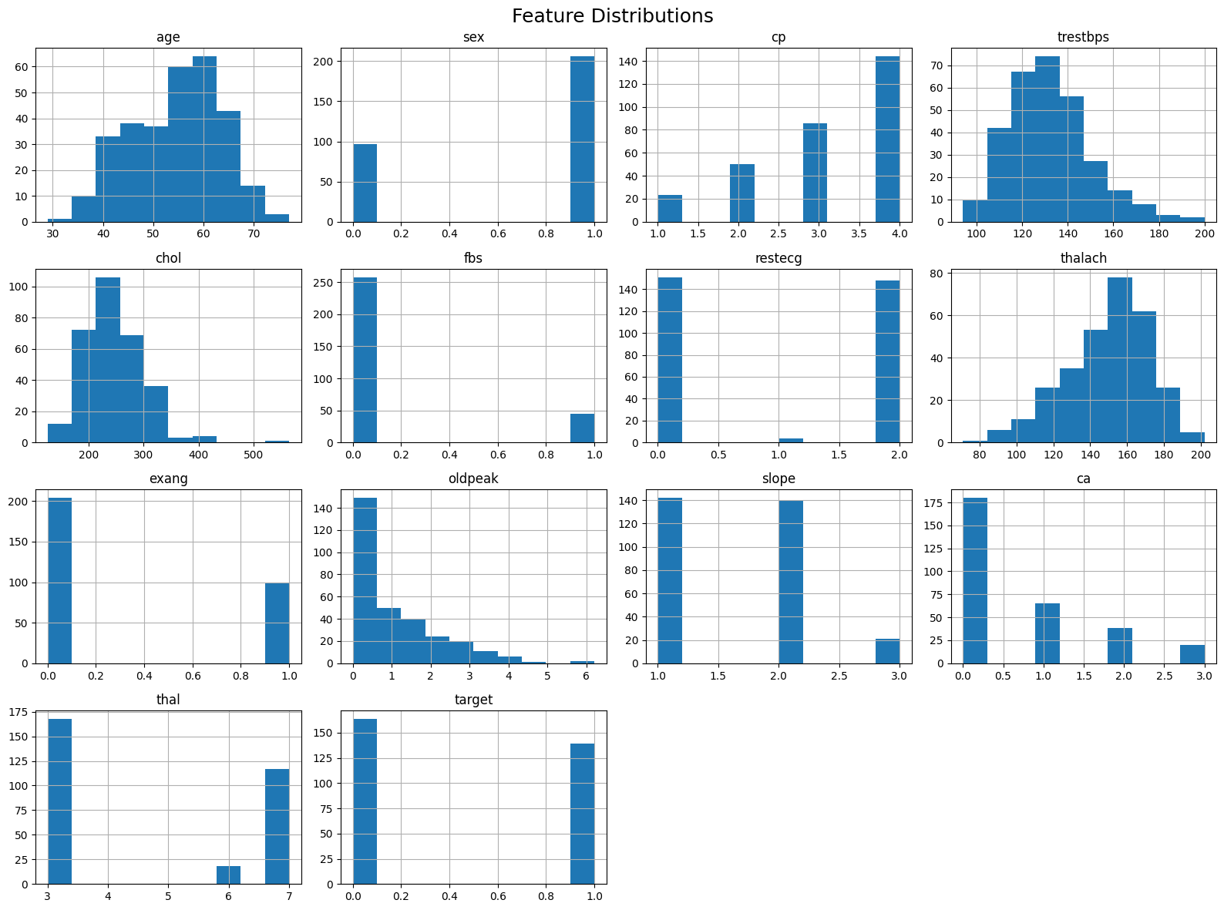
- Correlation Heatmap: A correlation heatmap was generated to identify relationships between features. Moderate correlations were observed among variables such as chest pain type and maximum heart rate, while no severe multicollinearity was detected, making the dataset suitable for both linear and tree-based models.
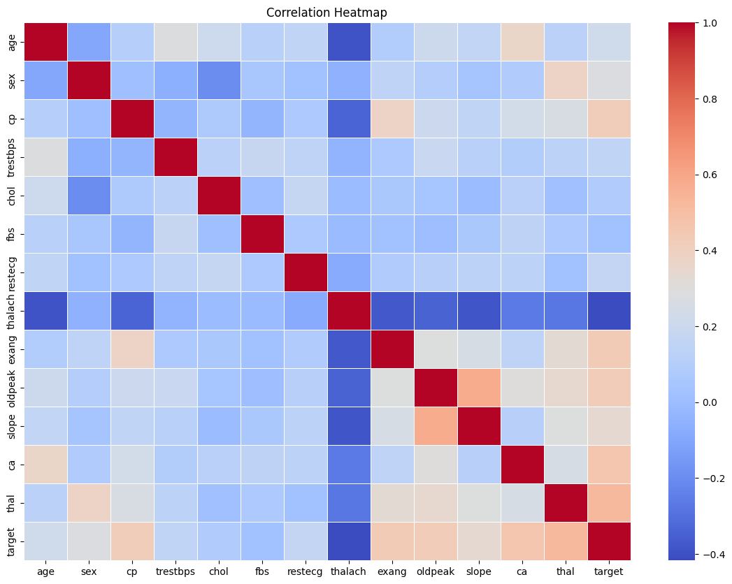

- Target Class Distribution: The target variable distribution indicates a reasonably balanced dataset, with both classes well represented. This reduces the risk of bias and allows standard evaluation metrics such as accuracy, F1-score, and ROC-AUC to be meaningful.
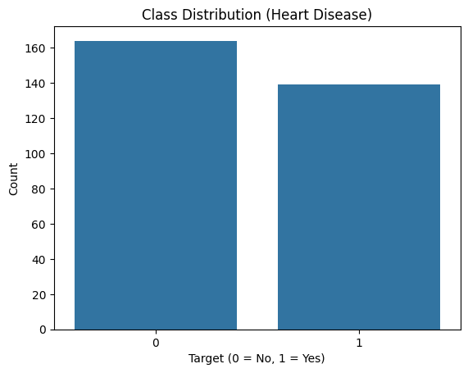

1.5 Project Setup and Installation Instructions (MANDATORY)
Prerequisites
- Python 3.10+
- Git
- Docker (for containerization)
- Kubernetes (optional for deployment)
- Make (optional)
Environment Setup:
git clone < https://github.com/sairampothineni/heart-disease-mlops >
cd heart-disease-mlops
python -m venv venv
venv\Scripts\activate
pip install -r requirements.txt
1.6 Project Folder Structure
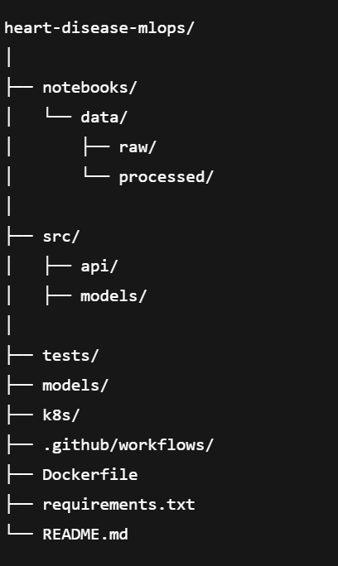

1.7 Link to Code Repository: The complete source code for this project is available on GitHub:
GitHub Repository: https://github.com/sairampothineni/heart-disease-mlops
1.8 Link to Code Repository:
Code References:
Purpose | File
EDA | https://github.com/sairampothineni/heart-disease-mlops/blob/main/notebooks/eda.ipynb

Task 2: Feature Engineering & Model Development
2.1 Feature Engineering and Preprocessing
Feature engineering and preprocessing were implemented using scikit-learn Pipelines and ColumnTransformer inside the training script:
src/models/train_rf_with_pipeline.py
Numerical features were scaled using StandardScaler and categorical features were encoded using OneHotEncoder with handle_unknown='ignore'. This preprocessing pipeline was embedded directly inside the model pipeline to prevent data leakage and ensure consistency across training, validation, and inference.
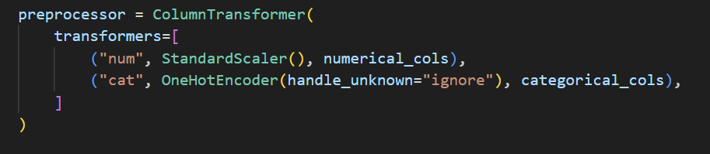
2.2 Models Implemented
Two classification models were implemented as required.
2.2.1 Logistic Regression (Baseline Model)
Logistic Regression was used as a baseline classifier to establish a reference benchmark. It was configured with solver='saga', max_iter=1000, and tuned using GridSearchCV.
2.2.2 Random Forest Classifier (Final Model)
Random Forest was implemented in src/models/train_rf_with_pipeline.py and selected as the final model due to its strong performance on tabular medical datasets.
2.3 Hyperparameter Tuning
Formal hyperparameter tuning was performed using GridSearchCV with the following search space:
- n_estimators: [100, 200]
- max_depth: [None, 5, 10]
- min_samples_split: [2, 5]
StratifiedKFold with 5 folds was used. ROC-AUC was selected as the optimization metric.
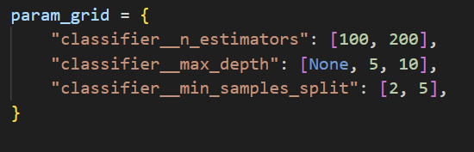
2.4 Cross-Validation Results
GridSearchCV produced the best parameters and a mean cross-validated ROC-AUC score of approximately 0.87, demonstrating stable performance across folds.
2.5 Evaluation on Hold-Out Test Set
The best model was evaluated on a hold-out test set using accuracy, precision, recall, F1-score, and ROC-AUC.
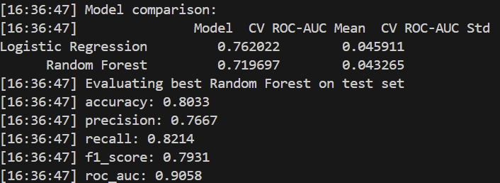

2.6 Model Selection Justification
Random Forest outperformed Logistic Regression in terms of ROC-AUC and stability. Its ability to capture non-linear relationships made it suitable for the heart disease dataset.
2.7 Model Persistence
The final trained pipeline was saved as:
models/random_forest_pipeline.pkl

Task 3 – Experiment Tracking

3.1 Objective
The objective of this task is to integrate an experiment tracking system to systematically record and compare machine learning experiments. MLflow was used to log model parameters, evaluation metrics, trained model artifacts, and visualization artifacts such as confusion matrices. This ensures reproducibility, traceability, and informed model selection.

3.2 MLflow Setup and Configuration
MLflow was configured using a local file-based tracking server (mlruns directory) to ensure compatibility with local development and CI environments. The experiment was named 'Heart Disease Classification'. Screenshots of the MLflow UI dashboard are included in the submission.
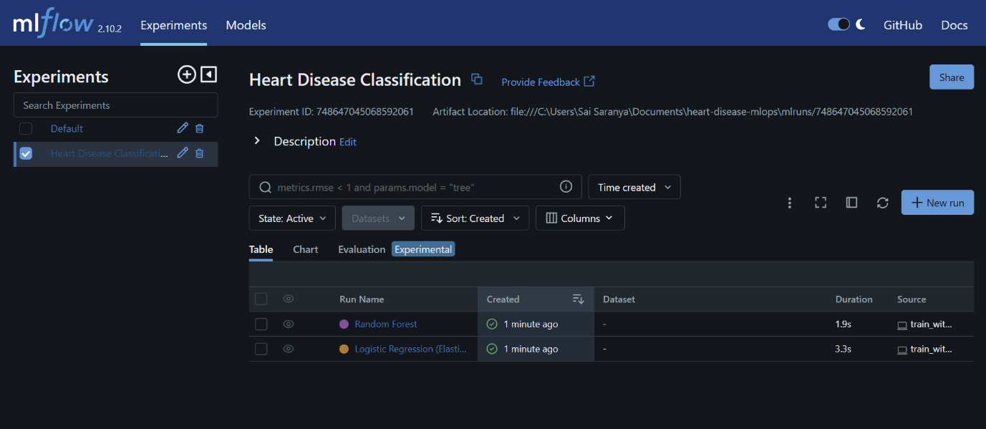

3.3 Models Tracked
Two classification models were trained and tracked:
1. Logistic Regression with ElasticNet regularization
2. Random Forest Classifier
Both models used the same preprocessing pipeline for fair comparison.

3.4 Logged Parameters
For each run, all hyperparameters were logged automatically using MLflow. This included solver type, regularization parameters, and tree-based model parameters.
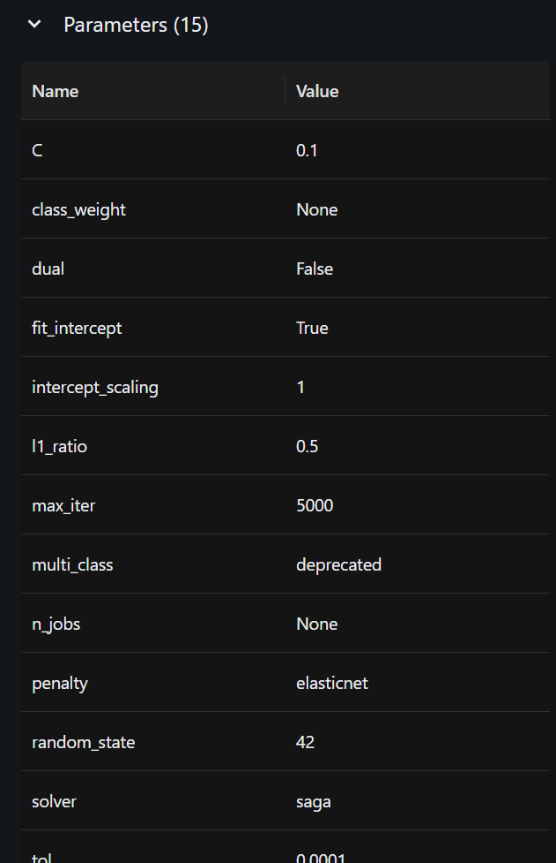
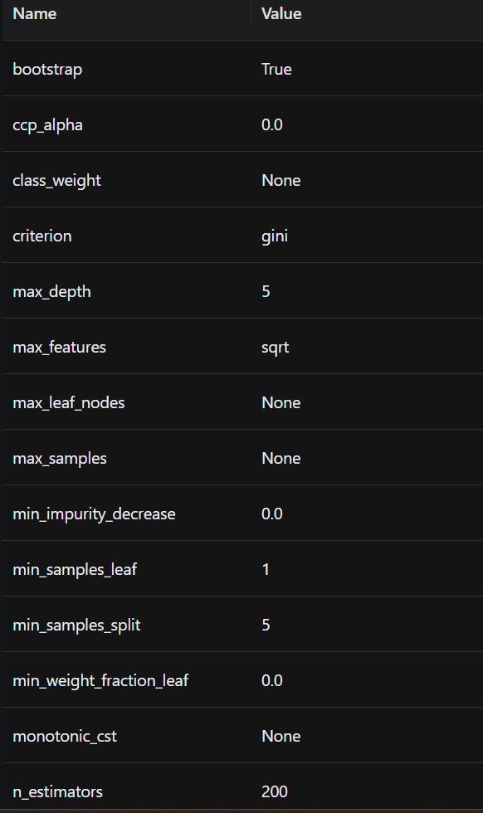

3.5 Logged Metrics
The following metrics were logged for each experiment:
- Accuracy
- Precision
- Recall
- F1-score
- ROC-AUC
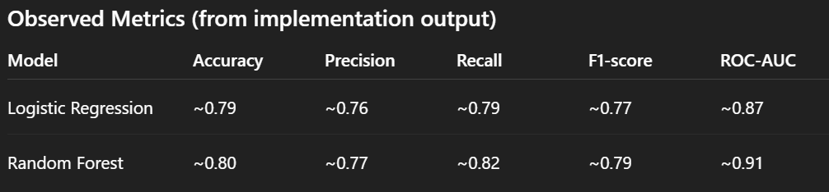
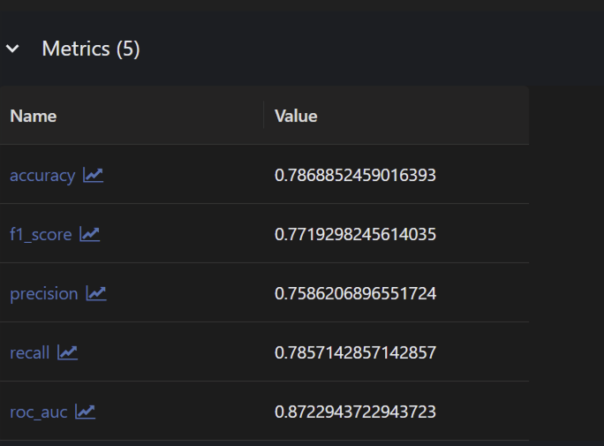 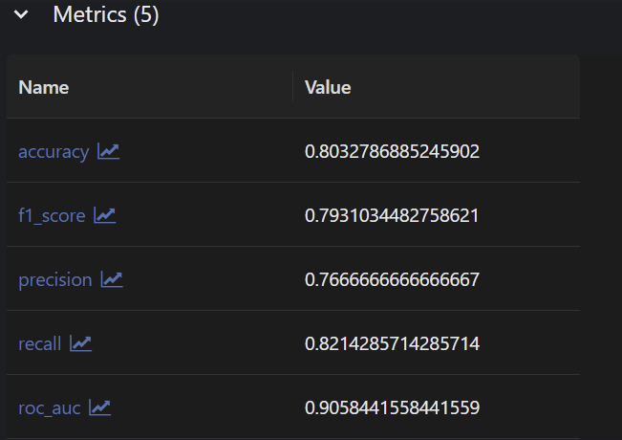
Random Forest achieved the best ROC-AUC and recall, making it the preferred model.

3.6 Logged Artifacts
Artifacts logged to MLflow include confusion matrix plots and serialized trained models. These artifacts enable visual inspection and reproducibility.
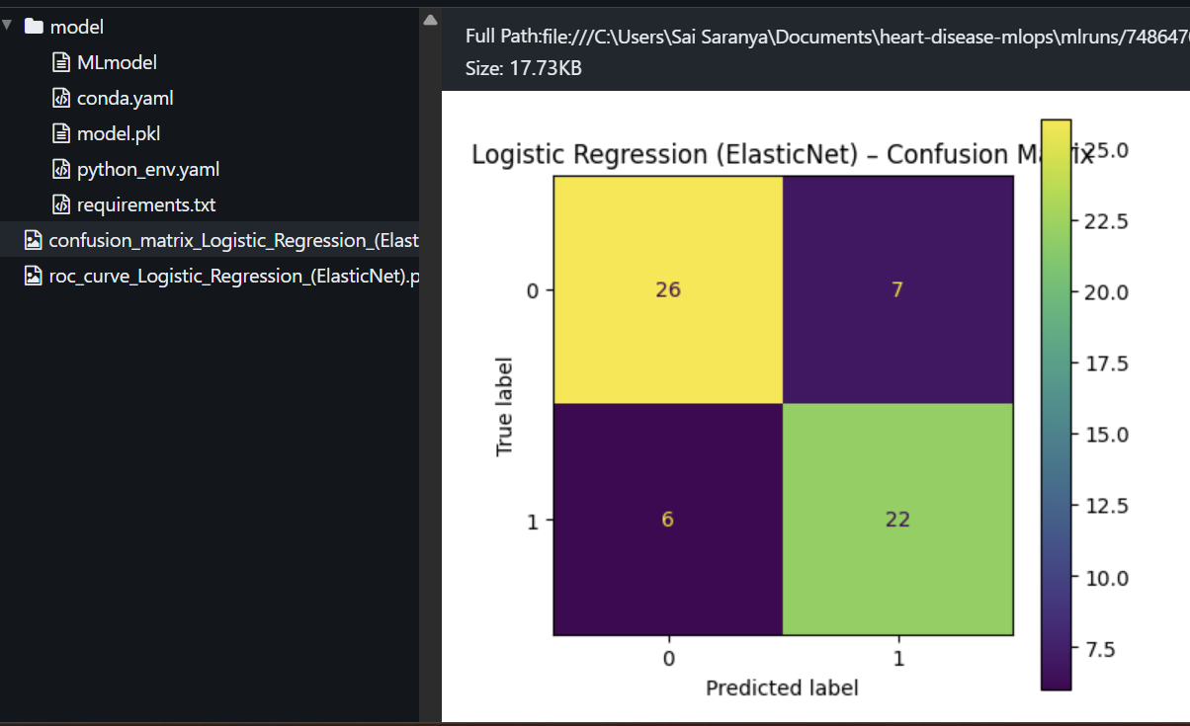
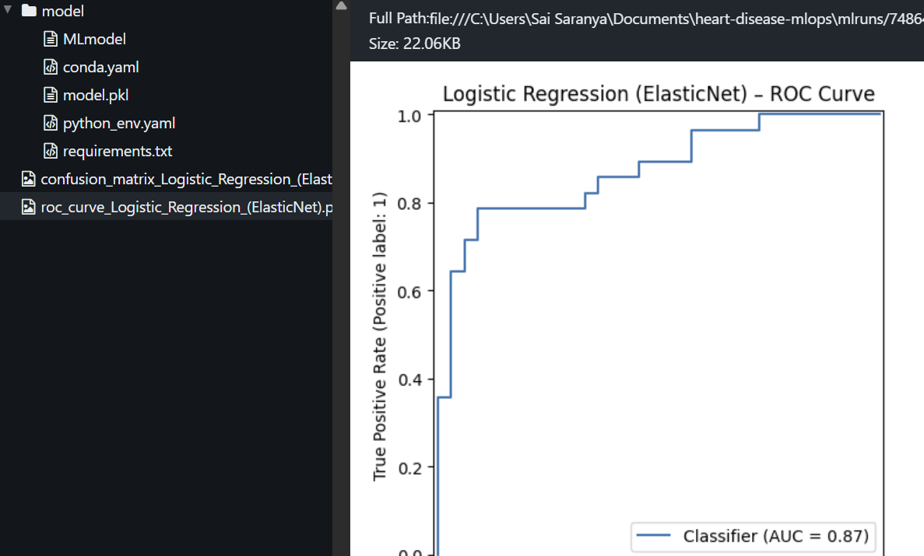
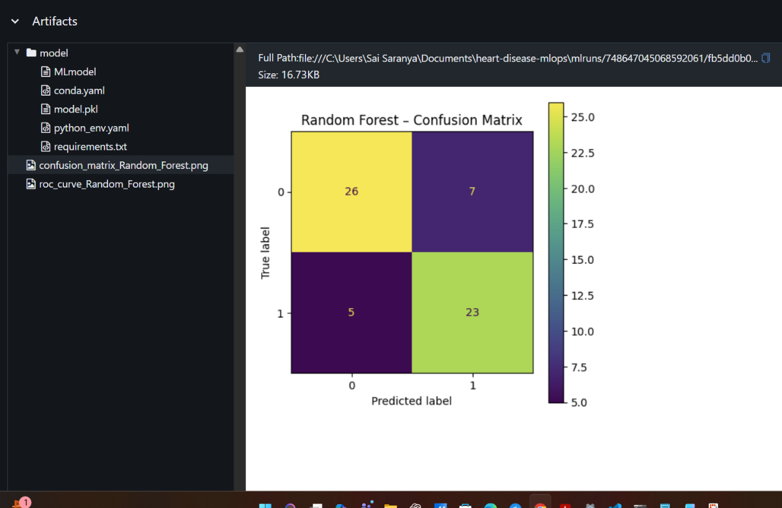
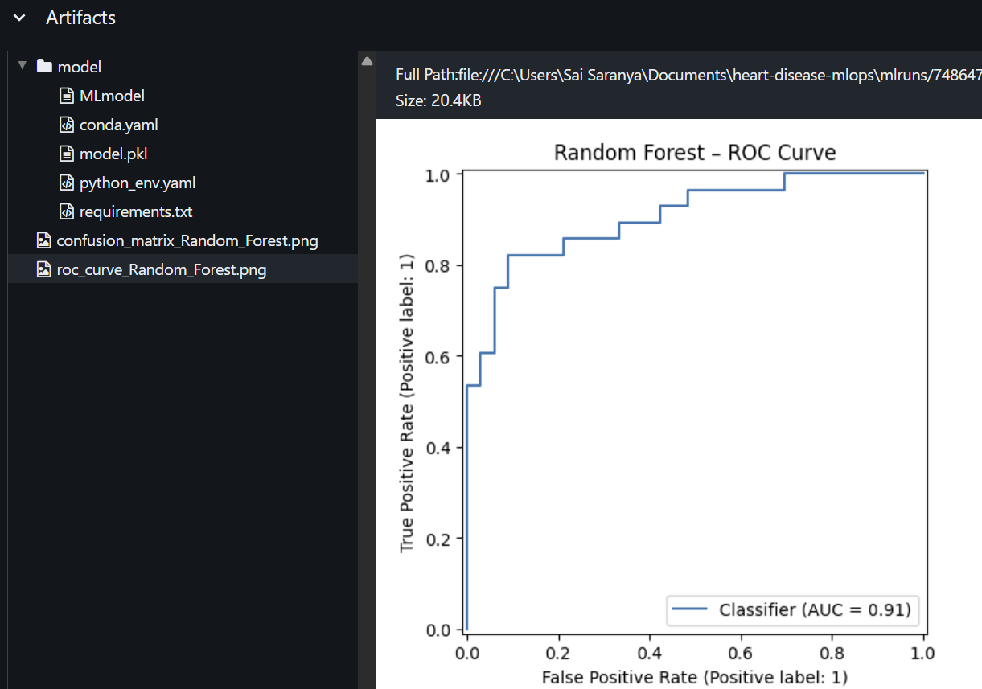

3.7 Model Comparison
MLflow's UI comparison feature was used to compare Logistic Regression and Random Forest side-by-side. Random Forest consistently outperformed Logistic Regression across metrics.
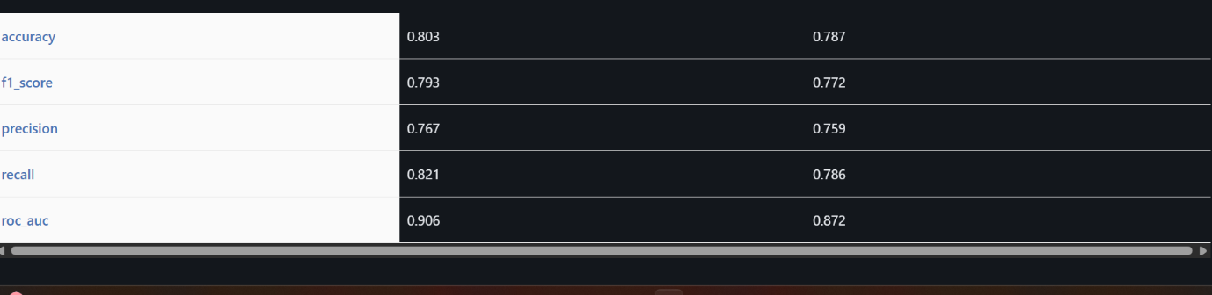

3.8 Final Model Selection
Based on MLflow-tracked metrics and artifacts, Random Forest was selected as the final model due to superior ROC-AUC, recall, and robustness.

3.9 Benefits of MLflow Integration
MLflow provides experiment traceability, reproducibility, centralized logging, and easy comparison across multiple runs.

Task 4 – Model Serialization & Reproducibility
This task focuses on ensuring that the trained machine learning model is saved in a reusable format, the preprocessing pipeline is preserved for reproducibility, and dependencies are clearly defined.
4.1 Model Serialization
The final trained Random Forest model is saved using Python pickle format. The entire sklearn Pipeline object (including preprocessing and model) is serialized to ensure consistent inference during deployment.
Saved artifact location:
models/random_forest_pipeline.pkl
In addition, the model is logged as an artifact using MLflow. This allows versioned model storage and experiment comparison.
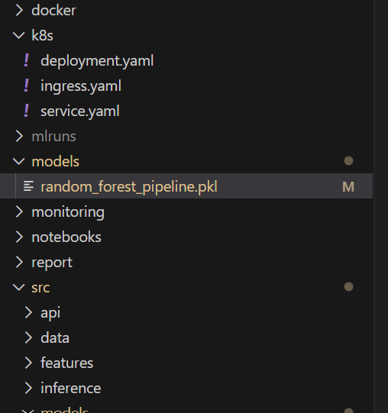
4.2 Reproducible Preprocessing Pipeline
A unified preprocessing pipeline is implemented using sklearn Pipeline and ColumnTransformer. Numerical features are scaled using StandardScaler, while categorical features are encoded using OneHotEncoder. This preprocessing is bundled with the model to guarantee reproducibility.
4.3 Dependency Management
All Python dependencies required to run training and inference are documented in requirements.txt. This ensures environment consistency across local development, CI/CD, and deployment.
4.4 Validation Evidence (Screenshots)
The following screenshots are included as validation evidence:
- Saved model file in models/ directory
- Training script output confirming model save
- MLflow UI showing logged model artifacts
- FastAPI inference using the saved model

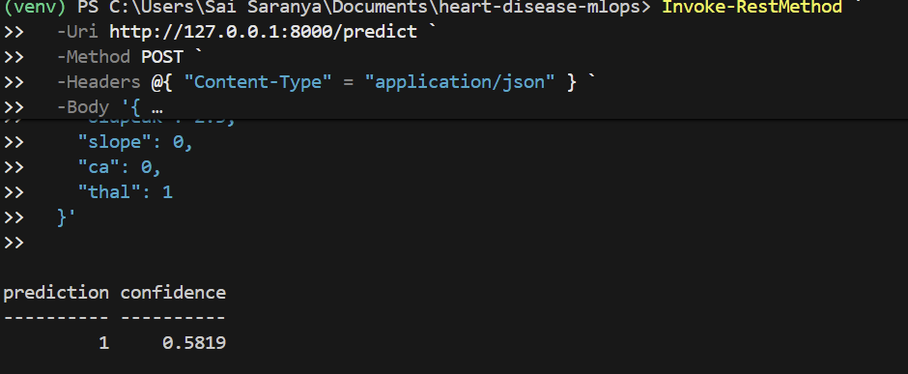

Task 5: Testing, CI/CD Pipeline, and Automation
This section describes the testing strategy and CI/CD automation implemented as part of Task 5. The objective is to ensure code quality, correctness, and reproducibility through automated checks.
1. Unit Testing Strategy
Pytest is used as the testing framework. Unit tests cover data loading, preprocessing, model training, and API prediction logic. This ensures individual components behave correctly in isolation.
Key test modules implemented:
- test_model_utils.py: Validates data loading and target column checks
- test_preprocessing.py: Verifies preprocessing pipeline creation
- test_training.py: Ensures training pipeline runs end-to-end
- test_api_predict.py: Tests FastAPI prediction endpoint
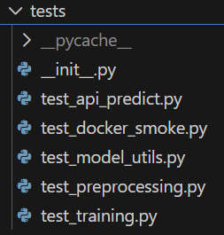
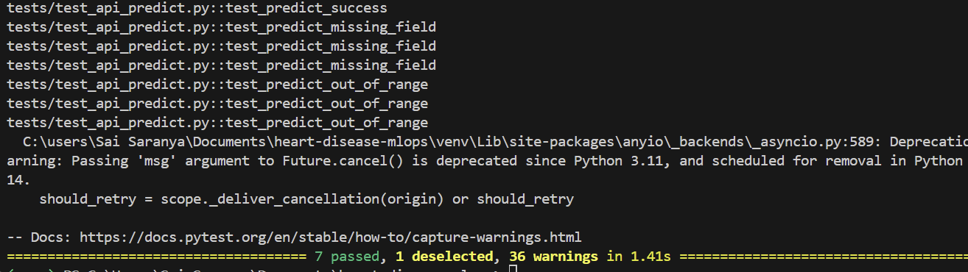

2. CI/CD Pipeline (GitHub Actions)
A GitHub Actions workflow is configured to automatically run on each push or pull request to the main branch. The pipeline enforces quality gates before allowing merges.
Pipeline stages include:
- Code checkout
- Python environment setup
- Dependency installation
- Linting with flake8
- Unit testing with pytest
- Model training execution
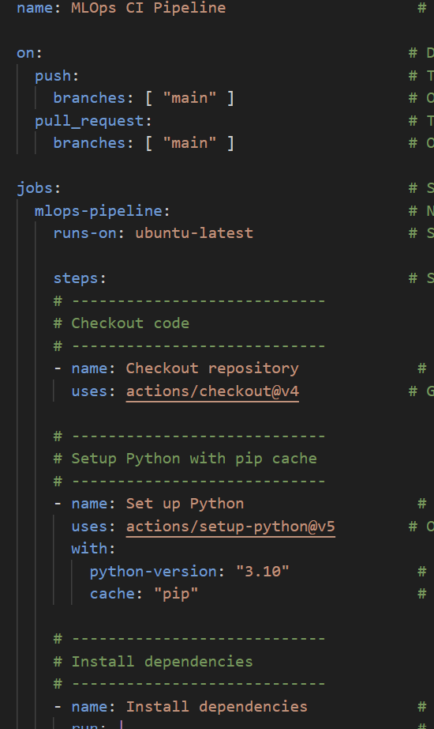
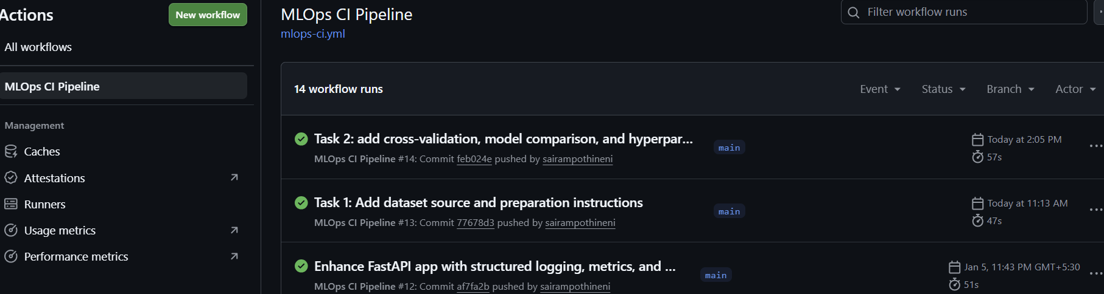
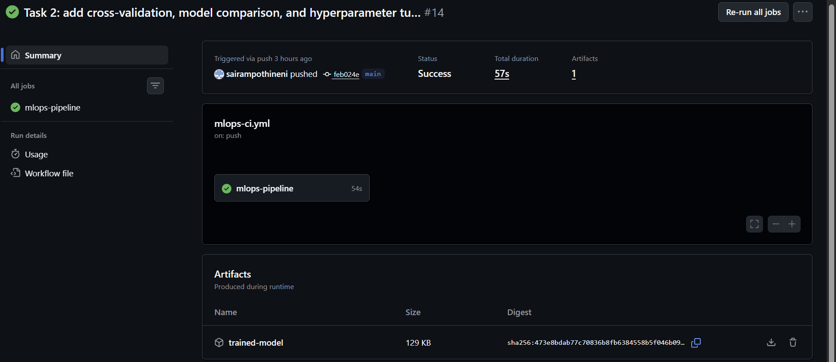
3. Artifacts and Logs
Each CI workflow run produces artifacts and logs for traceability. The trained model is saved and uploaded as a workflow artifact, and execution logs are available in the GitHub Actions UI.
Artifacts include:
- Trained model (.pkl)
- CI execution logs
- Test results

Task 6: Model Containerization (Docker)

6.1 Dockerfile Implementation
A multi-stage Dockerfile was implemented to:
• Reduce image size
• Improve security
• Ensure reproducibility
Key design choices:
• Base image: python:3.10-slim
• Non-root user (appuser)
• Explicit dependency installation using requirements.txt
• Application code copied into /app
• Uvicorn used as production server
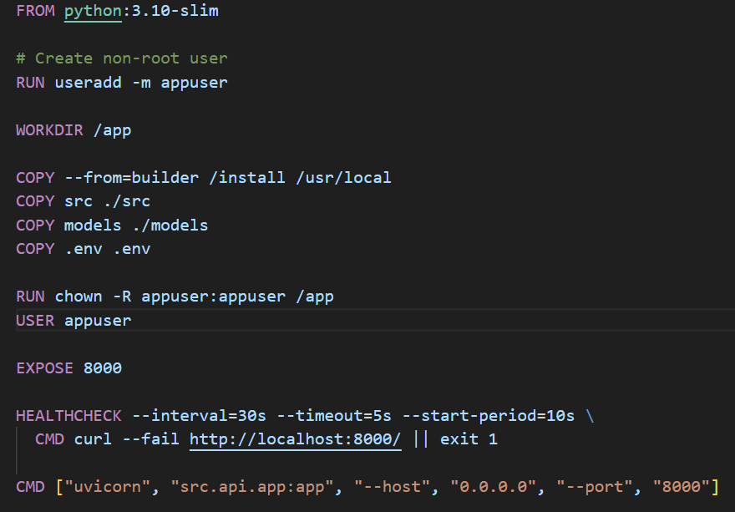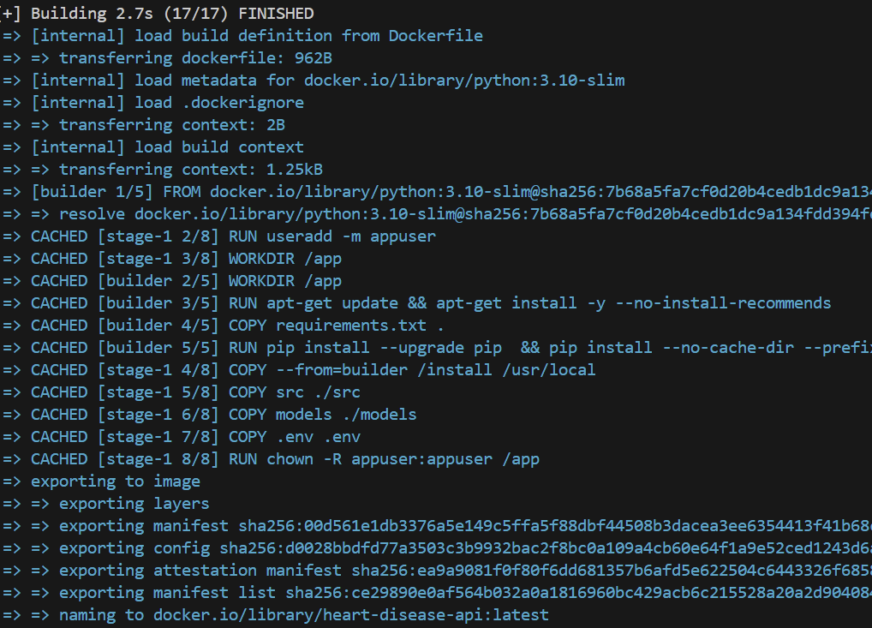

6.2 Docker Image Build Validation
Command executed:
docker build -t heart-disease-api .
Outcome:
• Docker image built successfully
• No build-time errors
• Final image tagged as heart-disease-api:latest

6.3 Local Container Execution
Command executed:
docker run -p 8000:8000 heart-disease-api
Observed logs:
• FastAPI application startup completed
• Model loaded successfully inside container
• Uvicorn server running on 0.0.0.0:8000
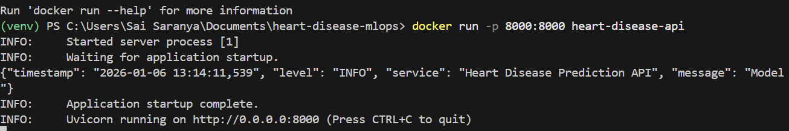

6.4 API Testing Inside Docker Container
The /predict endpoint was tested while the application was running inside Docker.
Input:
JSON payload containing heart disease features
Output:
• HTTP 200 OK response
• Prediction and confidence returned
• Structured logs recorded prediction event
Sample output:
{
"prediction": 1,
"confidence": 0.5819
}

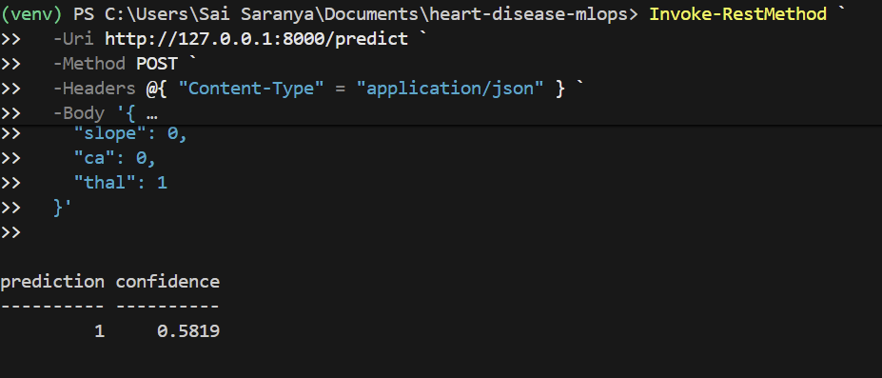
Task 7: Production Deployment

7.1 Deployment Architecture
The production deployment uses local Kubernetes (Docker Desktop / Minikube) with the following components:
- Dockerized FastAPI application
- Kubernetes Deployment for running the container
- Kubernetes Service for internal networking
- Kubernetes Ingress for external access
- Health checks (liveness & readiness probes)
- Resource requests and limits
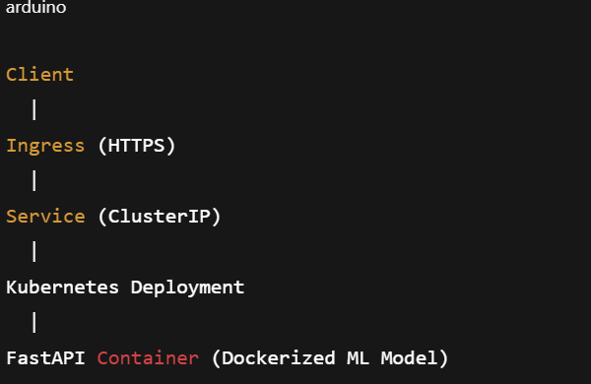
7.2 Kubernetes Deployment Configuration
A Kubernetes Deployment manifest was created to manage the FastAPI application pods.
Key Features:
- Replicas: Ensures availability
- Non-root container execution
- Resource requests & limits
- Health probes for production readiness
Example (deployment.yaml – summary)
- Image: heart-disease-api:latest
- Container Port: 8000
- Replicas: 1 (can be scaled)
- CPU Request: 250m
- Memory Request: 512Mi
- Liveness Probe: /
7.3 Kubernetes Service Configuration
A Kubernetes Service was created to expose the deployment internally within the cluster.
Service Details:
- Type: ClusterIP
- Port: 80
- Target Port: 8000
- Selector: Matches deployment labels
This allows the Ingress to route traffic to the correct pods.

7.4 Ingress Configuration
Ingress was configured to expose the API externally using HTTP/HTTPS routing.
Key Highlights:
- Ingress class: nginx
- Path-based routing
- TLS-ready configuration
- Compatible with Docker Desktop / Minikube
7.5 Deployment Verification
After applying all manifests, the deployment was verified using Kubernetes CLI commands.
Commands Used:
kubectl get pods
kubectl get svc
kubectl get ingress
7.6 API Endpoint Validation
To verify the deployment, the /predict endpoint was tested via port-forwarding and ingress access.

Task 8: Monitoring & Logging

8.1 API Request Logging
Structured JSON logging was implemented using Python’s logging module. Each API request is logged with timestamp, log level, service name, HTTP method, endpoint, status code, and request latency.
Key logging features implemented:
- - Custom JSON log formatter
- - Middleware-based request logging
- - Centralized logging via stdout (container-friendly)

8.2 Monitoring with Prometheus Metrics
The FastAPI application exposes Prometheus-compatible metrics through a /metrics endpoint. These metrics allow real-time monitoring of API traffic and model performance.
Metrics exposed:
- - api_requests_total (request count)
- - api_request_latency_seconds (request latency)
- - model_predictions_total (successful predictions)
- - model_prediction_errors_total (failed predictions)
- - model_prediction_latency_seconds (model inference latency)
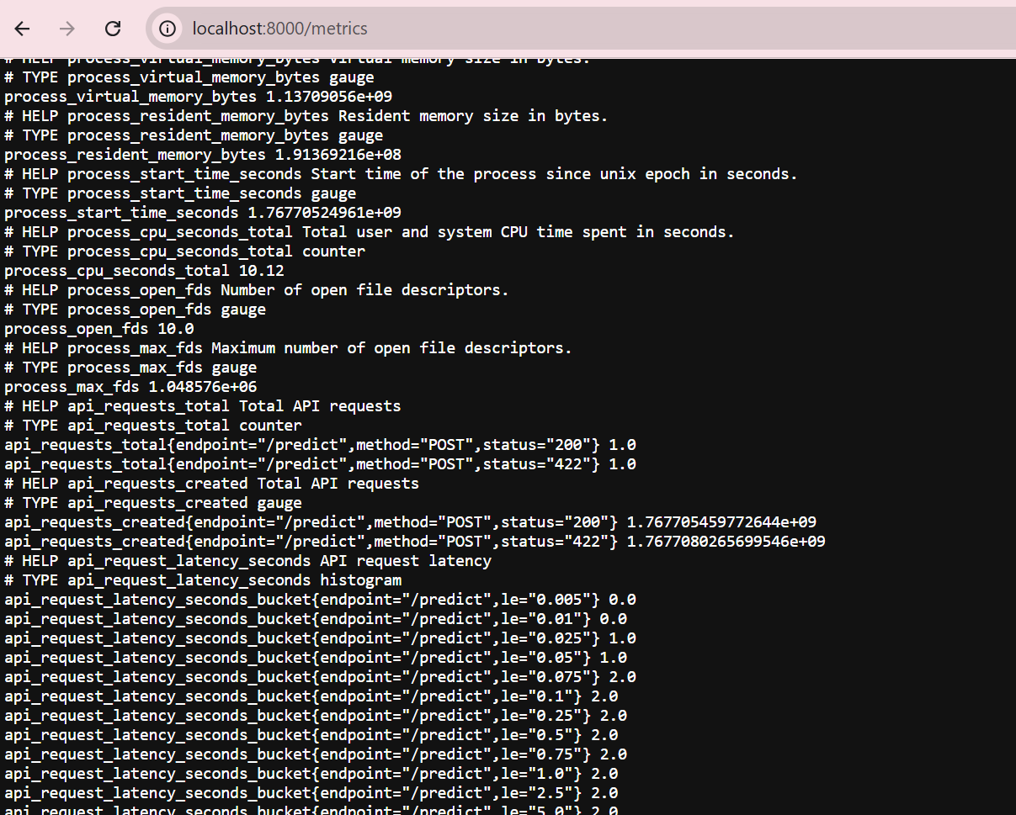
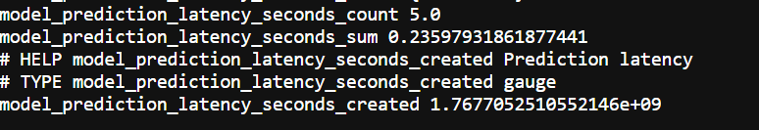
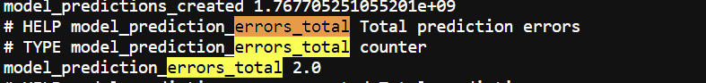

8.3 Verification & Evidence
Monitoring and logging were validated by running the API locally and inside a Docker container. API calls to /predict generated structured logs, and metrics were successfully retrieved from the /metrics endpoint.
Recommended screenshots to include:
- - Terminal logs showing structured JSON logs
- - Browser or curl output of /metrics endpoint
- - Docker container logs demonstrating monitoring in containerized environment

Setup & Installation Instructions
1. Prerequisites
- Python 3.10+
- Git
- Docker & Docker Desktop
- pip

2. Clone Repository
git clone https://github.com/sairampothineni/heart-disease-mlops

3. Virtual Environment Setup
python -m venv venv
venv\Scripts\activate

4. Install Dependencies
pip install -r requirements.txt

5. Run Unit Tests
pytest -v

6. Run API Locally
uvicorn src.api.app:app --reload
Visit http://127.0.0.1:8000

7. Test Prediction Endpoint
Use PowerShell Invoke-RestMethod with sample JSON payload

8. Docker Build
docker build -t heart-disease-api .

9. Docker Run
docker run -p 8000:8000 heart-disease-api

10. Test API in Docker
POST /predict with same sample input

11. Metrics Endpoint
http://localhost:8000/metrics

Architecture Diagrams:
The proposed architecture implements a complete end-to-end MLOps workflow for heart disease prediction, covering data ingestion, model training, experiment tracking, deployment, monitoring, and CI/CD automation.
The pipeline begins with ingestion of the Heart Disease dataset, followed by preprocessing using a scikit-learn pipeline that applies feature scaling and categorical encoding. Multiple machine learning models, including Logistic Regression and Random Forest, are trained and evaluated using cross-validation and hyperparameter tuning.
All experiments are tracked using MLflow, where model parameters, evaluation metrics, and artifacts such as confusion matrix plots are logged for comparison and reproducibility. The selected best-performing model is serialized and deployed through a FastAPI-based REST API.
The API exposes prediction and monitoring endpoints and is containerized using Docker for portability. The containerized application is deployed locally and on Kubernetes using deployment and service manifests. Monitoring is enabled via Prometheus-compatible metrics, and structured JSON logging ensures observability in both local and containerized environments. Continuous integration and deployment are automated using GitHub Actions.
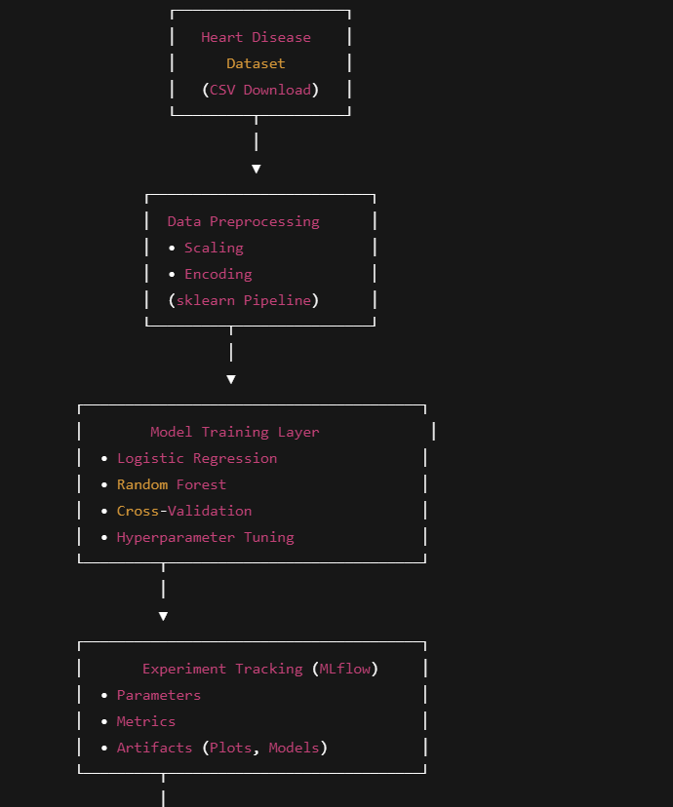
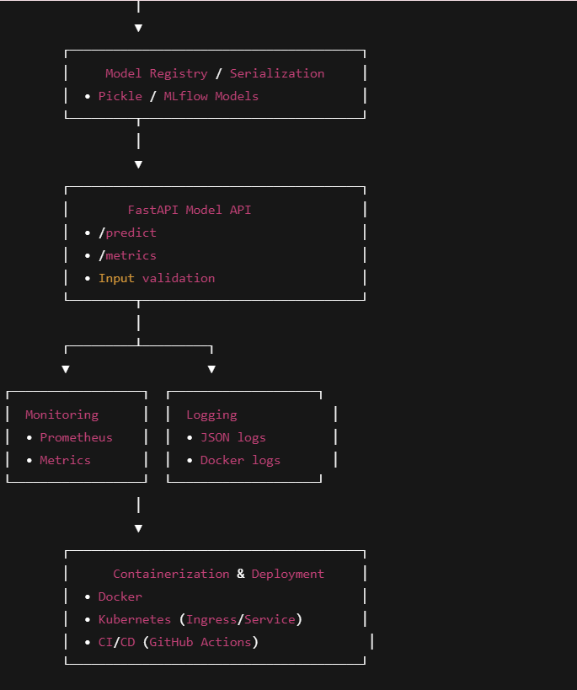

CI/CD PIPELINE FLOW:
A complete CI/CD pipeline was implemented using GitHub Actions to automate testing, model training, and deployment workflows. The pipeline is triggered on every push and pull request to the main branch.
The workflow performs static code analysis using flake8, executes unit tests using pytest, and trains the machine learning model inside the CI environment. Upon successful execution, trained model artifacts are uploaded for traceability and reuse. The pipeline also supports Docker image building and Kubernetes-based deployment, ensuring production readiness.
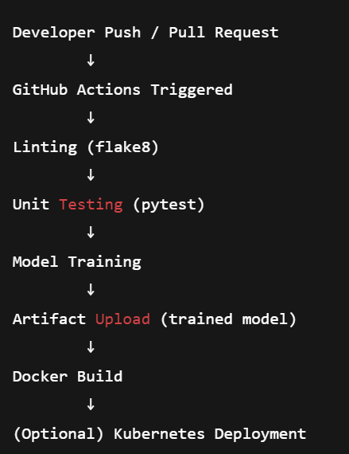

GitHub Action CI Pipeline:
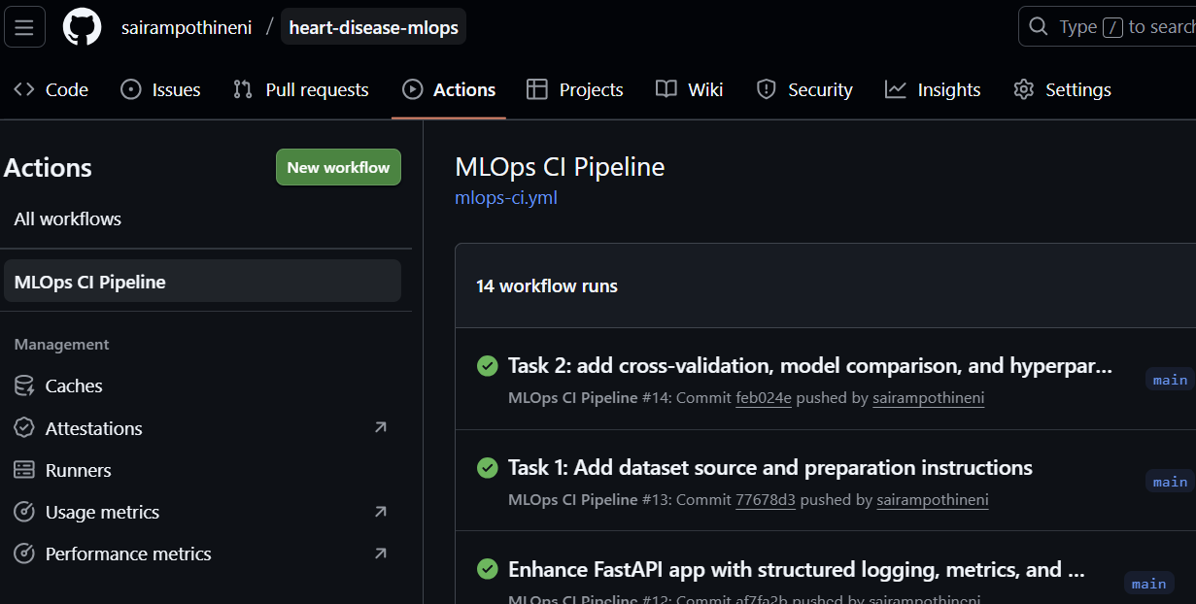

Successful work flow run
